**Lab 10: Multidimensional Lists**

Question1:

Write a function that returns the sum of all the elements in a specified column in a matrix using the following header:

**def** sumColumn(m, columnIndex):

Write a test program that reads a 3 * 4 matrix and displays the sum of each col- umn. Here is a sample run:

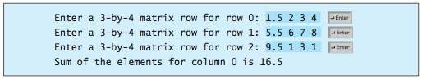

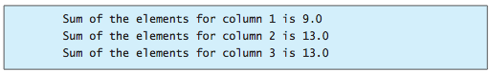

Question 2:

Write a function that sums all the numbers of the major diagonal in an *n* * *n* matrix of integers using the following header:

**def** sumMajorDiagonal(m):

The major diagonal is the diagonal that runs from the top left corner to the bottom right corner in the square matrix.

Write a test program that reads a 4 * 4 matrix and displays the sum of all its elements on the major diagonal. Here is a sample run:

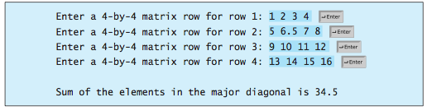

Question 3:

Write a program that randomly fills in **0**s and **1**s into a 4 * 4 matrix, prints the matrix, and finds the rows and columns with the most **1**s.

Here is a sample run of the program:

0011

0011

1101

1010

The largest row index: 2

The largest column index: 2, 3